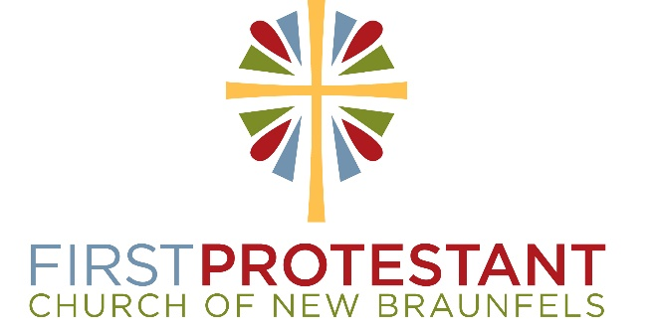

First Protestant Church of New Braunfels, Texas, is seeking a Senior Minister who will continue our 177-year tradition of Bible-based preaching, spiritual leadership, and service to our community. We are the founding church of the Evangelical Association of Reformed and Congregational Christian Churches.
Functions of the position include but are not limited to: Develop the ministry vision which sets the directions for church programs and missions; schedule, plan and conduct worship services, holiday observances and celebration of the sacraments; provide the primary preaching presence in both a traditional and contemporary worship service; act as chief administrator of the church and staff; conduct/review annual staff evaluations of all paid staff members. Other duties include officiating weddings and funerals, assisting with pastoral care and visitation and advisement of First Protestant School.
Minimum requirements and qualifications include but are not limited to: A visionary perspective for the church with an appreciation and respect for our church’s heritage; Ordained with a Master of Divinity or equivalent graduate degree in a related field; able to support our relationship with the Evangelical Association; significant experience as a minister with preaching responsibility. We seek a pastor with a passion for clear, Bible-based expository preaching to lead us in our mission to seek God, share His love and serve others.
We offer a generous salary and benefits package. Salary is commensurate with experience and qualifications.
For more information about this opportunity, please visit
https://firstprotestant.com/pastorinfo/
Please submit a resumé with cover letter to search@firstprotestant.com.

